**Meon**

**Glory Awaits You**

**Objective:**

* The objective of the player is to kill the enemy (in this case your opponent)

**Controls:**

Pick up weapon

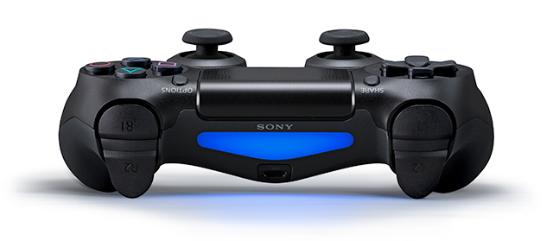

punch

Jump

Move

Shoot Weapon

**Special elements/ Power ups:**

* Power up that gives armor to the player.
* Powerupthat gives health points to the player.
* Power up that temporally increases the damage done by the player.